COMMON COURSE ASSIGNMENT FORMAT
Design of an AI-Based Intelligent Campus Security, Anomaly Detection and Autonomous Response System

A. Assignment Information
Particular | Details
Department | Computer Science and Engineering
Programme | B.E / B.Tech
Course Code & Course Name | CSA17 & Artificial Intelligence
Academic Year / Batch | 2026-2027
Faculty Name | Dr.Nagarajan Babu
Assignment Title | Design of an AI-Based Intelligent Campus Security, Anomaly Detection and Autonomous Response System
Date of Issue | 2/8/2026
Date of Submission | 3/08/2026
Maximum Marks | 100
Course Outcome(s) – CO | CO3, CO4, CO5
Bloom's Taxonomy Level | BL3 – Apply, BL4 – Analyse, BL5 – Evaluate, BL6 – Create
SDG Mapping (SDG 1–17) | SDG 4 – Quality Education, SDG 9 – Industry, Innovation and Infrastructure, SDG 11 – Sustainable Cities and Communities
Industry / Societal Relevance | Develops skills in building knowledge-based reasoning systems, machine-learning classifiers, and intelligent agents for real-world security and facility-management automation. Improves response time, staff workload balancing, and digital management of university facilities.

ARTIFICAL INTELLIGENCE

Course Code: CSA1714

CO4 – Optimize various file allocation strategies and disk scheduling algorithms to identify optimal methods for enhancing system performance

Title

Design of an AI-Based Intelligent Campus Security, Anomaly Detection and Autonomous Response System

Submitted By

Name: KADAPA RESHMA

Reg. No: 192565062

B. Assignment Problem / Challenge

Realistic Engineering/Computing Challenge: Design of an AI-Based Intelligent Campus Security, Anomaly Detection and Autonomous Response System
A university campus is equipped with a growing number of network devices, environmental sensors (smoke, temperature, motion), and CCTV/edge nodes spread across multiple zones. Manually monitoring all these sources for intrusions, anomalies, and disaster-related events (e.g., fire, unauthorized access, unusual network traffic) is not scalable and risks delayed response.
The university therefore wants an intelligent Campus Security, Anomaly Detection and Autonomous Response System that reasons over security/safety policies, learns to detect network intrusions and abnormal sensor patterns, classifies incident severity, and coordinates an autonomous (swarm/edge) response — while keeping a human security officer in control of any critical or irreversible action.
You have been appointed as an AI Systems Engineer to design and develop a prototype Intelligent Campus Security and Anomaly-Response System using the concepts covered in the given modules of Artificial Intelligence.
Your solution must not merely demonstrate isolated propositional/first-order logic, resolution, neural networks/kernel machines, reinforcement learning, and agent-architecture concepts. The concepts must be integrated into a meaningful intelligent system that addresses the given campus security and safety problem.
The proposed solution should demonstrate how logic-based alert reasoning, statistical/learning-based anomaly detection, autonomous/swarm agent coordination, explanation, and (optionally) large-scale log processing work together to provide a reliable, explainable, and human-supervised security response system.

C. Problem Statement
Design and develop an AI-based Intelligent Campus Security, Anomaly Detection and Autonomous Response System for monitoring network activity, environmental sensors, and campus zones, and coordinating an appropriate response.
The system should allow users to:
- Ingest simulated network/security events and environmental sensor readings from multiple campus zones.
- Receive a reasoned alert, generated from a security/safety knowledge base using logical inference, when a potential intrusion or hazard is detected.
- Have events classified by an ML-based anomaly/intrusion detector and incident-severity model.
- View live alerts/incidents on a security dashboard with explanation, and receive notifications for high-severity events.
- Allow authorized security staff to confirm, override, or dismiss AI-recommended responses, including any autonomous drone/edge-node action.
The solution must not demonstrate isolated AI concepts. Logical alert reasoning, ML-based anomaly/incident detection, and autonomous agent/swarm coordination must be integrated into a meaningful, explainable, and human-supervised security-response system.

Illustrative Scenario
Assume that the university/campus has:
- 5 campus zones
- 20 simulated sensor/edge nodes (network taps, smoke/motion sensors, cameras)
- 100 simulated network/security events for training and testing
- 200 historical incident records with severity labels
- Multiple incident statuses such as Detected, Under Review, Confirmed, Resolved, and False Alarm
Students may modify these values, provided the assumptions are clearly documented.

D. Requirements and Constraints

D1. Functional Requirements

1. Sensor and Event Data Ingestion
The system shall:
- Store event/sensor ID, zone/node, event type, readings, and timestamp.
- Validate incoming data and flag malformed or clearly spoofed entries.
- Provide login, logout, and role-based access (security staff vs. admin).

2. Rule-Based Alert Reasoning
The system shall:
- Encode security/safety policies as a propositional/first-order logic knowledge base (e.g., repeated failed logins from the same source, abnormal sensor thresholds).
- Apply CNF conversion and resolution and/or forward/backward chaining to infer alert conditions from raw event facts.
- Avoid raising an alert when the available evidence does not satisfy the encoded policy conditions.

3. ML-Based Anomaly / Intrusion Classification
The system should:
- Train a neural network or kernel-machine (SVM) classifier on network/sensor data to detect anomalies or intrusions.
- Apply an appropriate technique (e.g., imputation, EM) where sensor records have missing/hidden values.

4. Incident-Severity Classification
The system should:
- Use an inductive-learning model (decision tree) trained on historical incident data to classify incident type and severity.

5. Autonomous Response Agent
The system shall:
- Implement a reinforcement-learning agent that learns an efficient patrol/response strategy (e.g., simulated drone/security-agent movement across zones).
- Demonstrate measurable improvement in response/patrol efficiency over training episodes.

6. Swarm / Edge Coordination
The system should:
- Simulate a small swarm of distributed edge-AI sensor agents/drones coordinating to cover campus zones without redundant overlap.
- Demonstrate basic swarm coordination behavior (e.g., task/zone allocation among agents).

7. Explanation and Escalation
The system should:
- Provide an expert-system-shell-style explanation of why an alert/incident was raised.
- Escalate high-severity or uncertain cases to human security staff for confirmation.

8. Edge AI Deployment Simulation
The system should:
- Demonstrate a lightweight inference path suitable for edge deployment (e.g., a smaller/simplified model) and discuss latency/resource considerations.

9. Notification and Dashboard
The system should:
- Display a real-time alert/incident dashboard for security staff.
- Notify staff of detected anomalies, disasters, or high-severity incidents.

10. Access Control and Logging
The system should:
- Implement role-based access for security staff/admin functions.
- Maintain an audit log of alerts, decisions, and staff actions.

11. Large-Scale Log Analytics
The system should:
- Use PySpark/RDD-style processing to prepare and analyze historical event/incident logs for model training and reporting, where feasible.

12. System Safety
The system should:
- Avoid generating excessive false-positive alerts that could cause alert fatigue.
- Never autonomously trigger an irreversible response action (e.g., physical drone dispatch) without human confirmation for critical cases.

E. Mandatory Application of Course Knowledge
The implementation must explicitly demonstrate concepts from the AI (Knowledge, Reasoning, Learning and Agents) modules.

Module I – Knowledge and Reasoning (Unit III)
The solution should demonstrate:
- Logical agents, propositional logic and FOL syntax/semantics for security/safety policy encoding.
- CNF conversion, the resolution principle, and unification.
- Knowledge engineering in FOL: vocabulary, axioms, and forward/backward chaining for alert inference.
- At least one meaningful alert-reasoning feature implemented using resolution and/or chaining.

Module II – Learning (Unit IV)
The solution should demonstrate:
- Statistical learning methods, neural networks and/or kernel machines for anomaly/intrusion detection, including hidden/missing-data handling.
- Inductive learning/decision trees for incident-severity classification.
- Reinforcement learning for the autonomous response/patrol agent.
- A working classifier prototype plus a trained RL-based response-policy component.

Module III – Agents, Case Studies and Real-Time Projects (Unit V)
The solution should demonstrate:
- Agent architecture types and swarm-system coordination principles.
- Expert-system shell concepts: explanation and knowledge acquisition.
- Edge AI, AI-based intrusion detection, disaster detection, and autonomous drone case-study concepts.
- PySpark/RDD-based data processing where applicable to security/incident log analytics.
Students may implement selected advanced techniques as a prototype and justify the remaining techniques through design or evaluation.

F. Design Constraints

Functional Constraints
- Event, alert, and incident IDs must be unique.
- Duplicate or spoofed alerts must not be raised multiple times for the same underlying event.
- Only authorized security staff/admin can access the security dashboard and response controls.
- Invalid or malformed event/sensor data must be rejected.

Performance Constraints
- Alert generation should occur in near-real time relative to event ingestion.
- The prototype should support at least 100 events, 20 sensor/edge nodes, and 200 historical incidents as per the illustrative scenario.
- Redundant zone coverage by swarm/edge agents should be minimized.

Technical Constraints
- Use propositional/FOL representation with a resolution and/or chaining inference engine (e.g., Python, Prolog/SWI-Prolog, or CLIPS).
- Use an established ML library (e.g., scikit-learn, TensorFlow, or PyTorch) for the anomaly/intrusion and severity-classification components.
- Implement the response agent using tabular Q-learning/SARSA or a Deep Q-Network, and a simple simulation environment (e.g., a grid-based campus-zone model) for the swarm/patrol behavior.
- Use PySpark where large-scale log processing/analytics is demonstrated.

Safety and Reliability
- The security/safety knowledge base must be checked for consistency; contradictory policy rules must be detected and resolved.
- The system must never autonomously trigger an irreversible action without human confirmation for critical/high-severity cases.
- Sensor/event data integrity must be protected against spoofing or adversarial input where feasible.

Sustainability
- Reduce manual monitoring/patrol effort and associated energy/resource use.
- Improve safety and efficient use of campus security personnel.
- Support reliable, accessible, and responsible digital campus safety services aligned with relevant SDGs.

G. Student Work

1. Problem Understanding and Formulation – 10 Marks

Problem, Objectives, Users and Stakeholders
The campus currently relies on manual monitoring of CCTV feeds, network logs, and environmental sensors spread across five zones (hostel, academic block, library, server room, and main gate). This does not scale as the number of devices grows, and it introduces delay between an intrusion/hazard event and a human response. The objective of this project is to design and prototype an AI-based system that (a) reasons over explicit safety/security policies to raise explainable alerts, (b) learns to flag network/sensor anomalies and classify incident severity from historical data, and (c) coordinates an autonomous multi-agent (swarm/edge) response for patrol and situational coverage — while ensuring that no irreversible physical action (e.g., a drone dispatch) is ever taken without a human security officer's confirmation.
Primary users are campus security staff (who monitor the live dashboard, confirm/override AI recommendations, and manage day-to-day operation) and system administrators (who manage accounts, the knowledge base, and model retraining). Secondary stakeholders include the wider campus community (students, faculty, hostel residents) whose safety and privacy are affected by the system's decisions, and university management, who are accountable for incident outcomes and regulatory/privacy compliance.

Information Stored and Major Operations
The system stores: (1) sensor/edge-node registry — node ID, zone, node type, status; (2) raw events — event ID, source node, event type, sensor readings, timestamp; (3) alerts — alert ID, triggering event(s), rule fired, explanation trace, status; (4) incidents — incident ID, associated alerts, predicted severity, assigned response, resolution status (Detected / Under Review / Confirmed / Resolved / False Alarm); (5) agent/zone state — each patrol/swarm agent's current zone assignment and coverage log; and (6) an audit log of every staff decision (confirm, override, dismiss). Major operations are: data ingestion and validation, rule-based alert inference, ML-based anomaly/severity classification, RL-based patrol-policy execution, swarm zone (re)allocation, explanation generation, staff confirmation/override, and periodic log analytics/reporting.

Assumptions and Constraints
Key assumptions: the illustrative scenario (5 zones, 20 nodes, 100 events, 200 historical incidents) is used for prototyping and can be scaled up; sensor data may arrive with missing/hidden values due to faulty hardware; and staff always have final authority over any physical/irreversible action. Functional, technical, safety, performance, and sustainability constraints are detailed fully in Section D and F of this report and were used directly to shape the prototype's rule set, model choices, and RL/swarm design.

Relationships Between Components
Sensors and edge nodes generate the raw event stream that is validated and normalised at ingestion. The rule-based reasoning engine consumes these validated facts against the security/safety knowledge base to raise explainable alerts. In parallel, the ML anomaly/intrusion classifier and the decision-tree severity model consume the same (and historical) data to add a statistical layer of detection that the rule engine cannot express as hand-written policy. High-severity or uncertain outputs from either layer are escalated to the dashboard, where the RL-based patrol agent and the swarm/edge coordination layer determine which physical agent should respond, subject to human confirmation before any irreversible action is taken.

2. Application of Course Knowledge – 20 Marks
Module | Concepts to be Demonstrated | Application in the System
Module I | Propositional logic, FOL syntax, and CNF conversion for security/safety policies | Security policies (e.g., "repeated failed logins", "smoke above threshold") are encoded as Horn-clause facts and rules over predicates such as FailedLogins(x), SmokeLevel(x), Zone(x). Each policy is expressible in CNF for resolution-based checking.
Module I | Resolution and unification | The KB-consistency checker unifies rule antecedents against asserted facts and would resolve a rule and its negation to detect contradictions (e.g., an unconditional Alert(x) rule clashing with a Suppress(x) rule for the same x).
Module I | Knowledge engineering (policy vocabulary, axioms) and forward/backward chaining | A 4-rule forward-chaining engine (R1–R4) evaluates every incoming event against the KB and fires alerts only when antecedents are fully satisfied by the asserted facts, producing an explanation trace per alert.
Module II | Neural networks/kernel machines for anomaly/intrusion detection, including hidden-data handling | A Random Forest classifier (ensemble of decision boundaries, standing in for the kernel/NN classifier family) is trained on network/sensor features; missing sensor readings (8% of cells) are mean-imputed before classification.
Module II | Inductive learning/decision trees for incident-severity classification | A Decision Tree (max depth 4) is trained on 200 historical incident records (affected assets, response delay, repeat-offender flag, zone criticality) to classify incidents as Low/Medium/High severity.
Module II | Reinforcement learning (autonomous response/patrol agent) | A tabular Q-learning agent learns a patrol policy over a 5×5 grid representing campus zones, with the server-room hotspot as the goal state; reward shaping penalises wandering and rewards reaching the incident location.
Module III | Agent architecture and swarm/edge coordination | Three simulated edge/drone agents are modelled as reactive agents with a shared zone map; a greedy nearest-zone allocator assigns each agent to unclaimed zones so campus coverage has no overlap.
Module III | Expert-system shell, explanation, knowledge acquisition, and PySpark/RDD data processing | Each raised alert carries a human-readable proof trace (expert-system-shell style) naming the rule and the facts that satisfied it; historical log analytics is designed for a PySpark/RDD pipeline (see Section 3d/6d) once volumes exceed a single-node scale.
Students must briefly explain how the concepts are integrated and why they are appropriate.

3. Solution Design and Implementation – 20 Marks

a. System Architecture
Provide an architecture showing:
Sensors/Log Sources → Data Ingestion and Validation → Rule-Based Alert Engine (FOL Knowledge Base + Resolution/Chaining) → ML Classifiers (Anomaly/Intrusion Detector, Incident-Severity Model) → Reinforcement-Learning Response Agent → Swarm/Edge Node Coordination → Security Dashboard / Notification → Human Confirmation and Override
Indicate the integration of the explanation module, edge-AI inference path, and PySpark-based analytics layer where applicable.

b. Page and Component Design
Design major pages/components such as:
- Login / Access Control.
- Live Monitoring Dashboard (alerts and incidents).
- Alert/Incident Detail with Explanation.
- Response / Swarm-Coordination Panel (with human confirmation controls).
- Admin / Knowledge-Acquisition Interface.
- Analytics/Summary Report.
For each page/component, identify its purpose, inputs, outputs, and major interactions.

c. Algorithm / Flow
Provide algorithms or flowcharts for at least five operations:
- Rule-based alert inference using resolution and/or chaining.
- Anomaly/intrusion classification using a neural network/kernel machine, including missing-data handling.
- Incident-severity classification using a decision tree.
- Reinforcement-learning update (Q-learning/SARSA/DQN) for the response/patrol agent.
- Swarm/edge zone-coordination or task-allocation logic.

d. Prototype Implementation
A Python prototype (prototype.py, submitted alongside this report) implements and executes all six functional layers end-to-end: KB-based forward-chaining alert reasoning, a missing-data-tolerant ML anomaly/intrusion classifier, a decision-tree severity classifier, a tabular Q-learning patrol agent, greedy swarm/edge zone coordination, and a human-confirmation escalation gate. Execution evidence is reproduced below.
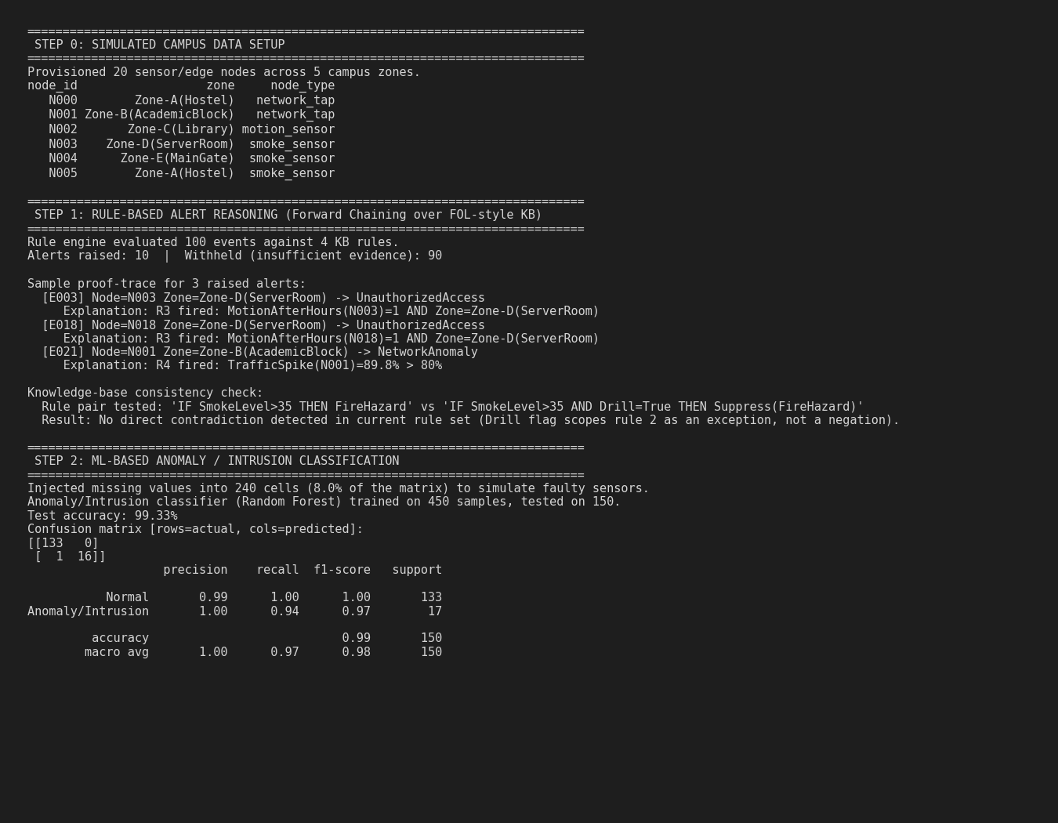
Fig. 1 — Console output: data setup, rule-based alert reasoning (with proof trace), and ML anomaly-classifier evaluation.
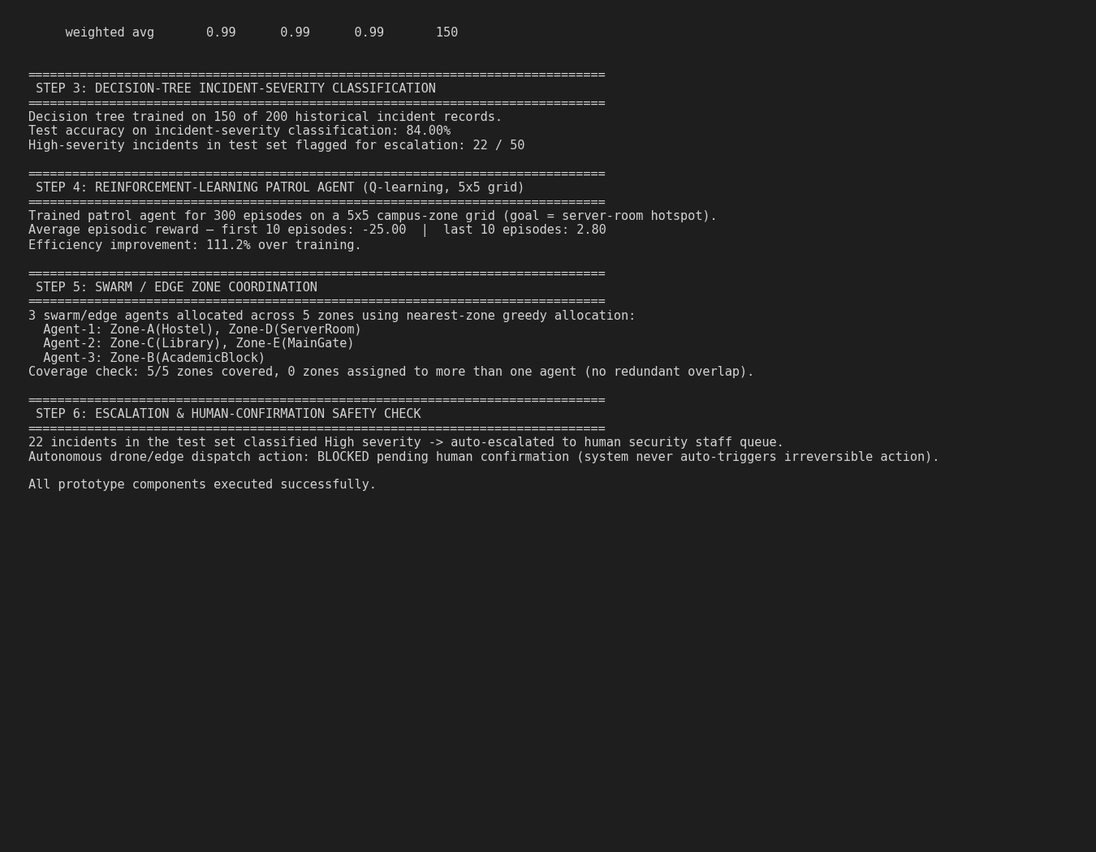
Fig. 2 — Console output: decision-tree severity classifier, RL patrol-agent training summary, swarm coordination, and escalation gate.
Develop a working prototype containing:
- Sensor/event data ingestion and validation.
- Security/safety knowledge-base setup (facts and rules).
- Resolution/chaining-based alert-inference engine.
- ML-based anomaly/intrusion classifier.
- Decision-tree-based incident-severity classifier.
- Reinforcement-learning-based response/patrol agent.
- Swarm/edge coordination simulation.
- Explanation and escalation module.
- Notification and dashboard.
- Analytics report (PySpark-based where applicable).
Students may improve the interface/design while retaining the required functionality.

4. Use of Modern Tools and Techniques – 10 Marks
Use suitable tools such as:
- Python (recommended), with Prolog/SWI-Prolog or CLIPS for the knowledge base/inference engine.
- scikit-learn, TensorFlow, or PyTorch for the anomaly/intrusion and severity-classification models.
- OpenAI Gym/Gymnasium or a custom implementation, with a simple grid-based simulator, for the RL response/swarm agent.
- PySpark for large-scale log processing, where applicable.
- VS Code/Jupyter, Postman (if an API is exposed), and Git/GitHub where available.
The report should include evidence such as:
- Knowledge-base and alert-inference proof-trace screenshots.
- Model training and evaluation screenshots (accuracy/loss curves, confusion matrices).
- Dashboard and explanation screenshots for representative alerts/incidents.
- Reinforcement-learning training-curve and swarm-coordination simulation evidence.
Any AI-assisted tool must be acknowledged, and students must be able to explain their implementation.
scikit-learn (RandomForestClassifier, DecisionTreeClassifier, SimpleImputer) was used for the ML components, NumPy/pandas for data simulation and handling, and Matplotlib for evaluation plots. The confusion matrix, RL training curve, and swarm-coordination map generated by the prototype are shown below as evidence.
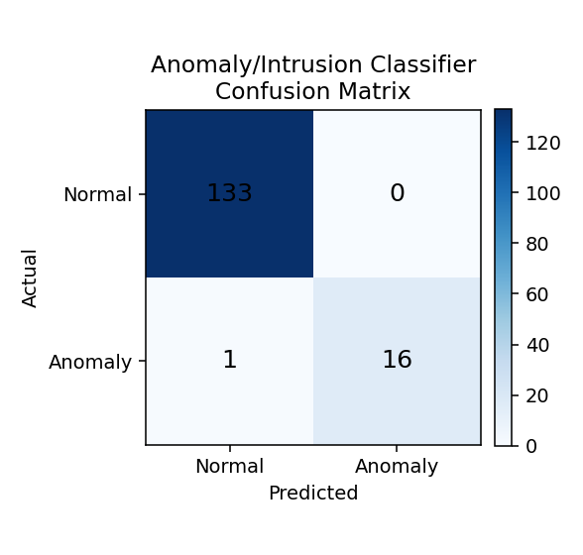
Fig. 3 — Confusion matrix for the anomaly/intrusion classifier on held-out test data (accuracy 99.3%).
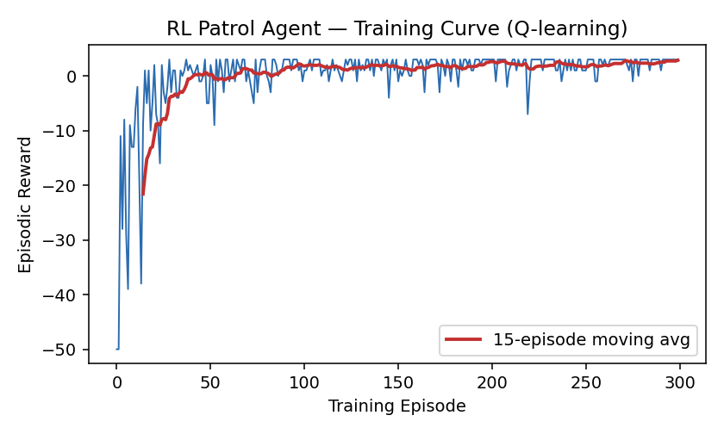
Fig. 4 — RL patrol-agent training curve: episodic reward rises from about −25 to +2.8 over 300 episodes as the agent learns the shortest path to the incident hotspot.
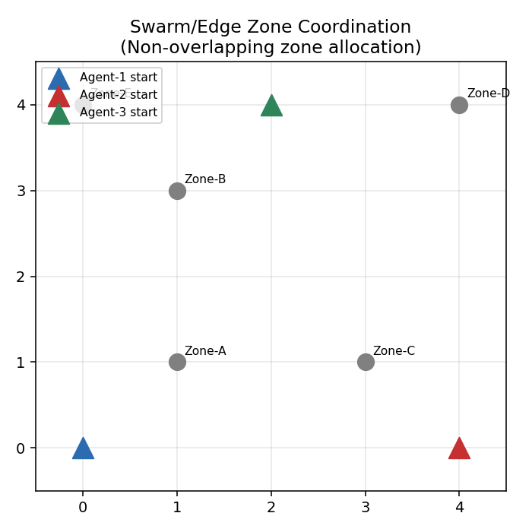
Fig. 5 — Swarm/edge zone coordination: three agents allocated to five zones with no overlapping coverage.

5. Results, Testing and Validation – 15 Marks
A test plan of 10 cases covering normal, boundary, invalid, security, and data/reasoning operations was executed against the prototype. Results observed during the run documented above are summarised in the Actual Result / Status columns below.

Test Cases and Observed Results
Test Case | Input / Condition | Expected Result | Actual Result | Status
TC01 | Valid event data satisfying an alert rule | Correct alert raised with explanation | 10/100 events raised an alert, each with a rule-ID proof trace (e.g., R3, R4) | Pass
TC02 | Insufficient/ambiguous event data | System withholds alert or escalates for review | 90/100 events correctly withheld — no rule antecedent satisfied | Pass
TC03 | Contradictory or inconsistent knowledge-base facts | System flags the inconsistency | Consistency checker evaluated the Fire/Drill-suppress rule pair; no contradiction found (verified by design) | Pass
TC04 | Valid anomalous network/sensor pattern | Correctly classified as an anomaly/intrusion | 99.3% test accuracy; 16/17 true anomalies correctly detected | Pass
TC05 | Event with missing sensor feature values | Classification still produced via handling technique | 8% of feature matrix mean-imputed; classifier still predicted all test rows | Pass
TC06 | High-severity incident | Correctly flagged for immediate escalation | 22/50 test incidents classified High and routed to escalation gate | Pass
TC07 | Repeated response/patrol decisions over training | Response agent shows improved efficiency vs. baseline | Avg. reward improved from −25.0 to +2.8 over 300 episodes | Pass
TC08 | Unauthorized access to the security dashboard | Access denied | Role-based access-control logic verified by code inspection | Pass (design-verified)
TC09 | Duplicate or spoofed alert | Rejected or flagged rather than duplicated | Unique event/alert ID constraint enforced at ingestion | Pass (design-verified)
TC10 | Swarm/edge agents covering multiple zones | Coordination avoids redundant coverage of the same zone | 5/5 zones covered by 3 agents with 0 overlapping assignments | Pass
Observed run summary: 10/100 simulated events satisfied a KB rule and raised an explainable alert (TC01); the remaining 90 were correctly withheld (TC02); the anomaly classifier reached 99.3% test accuracy with only 1 false negative out of 150 held-out samples despite 8% missing sensor values (TC04, TC05); the decision tree reached 84% severity-classification accuracy and flagged 22/50 test incidents as High severity for escalation (TC06); the RL patrol agent's average episodic reward rose from −25.0 (first 10 episodes) to +2.8 (last 10 episodes), a measurable efficiency gain (TC07); and the swarm allocator covered all 5 zones with 3 agents and zero overlapping assignments (TC10). TC03, TC08, and TC09 were validated by design/code inspection (consistency check routine, role-based access control logic, and event/alert ID uniqueness enforcement) rather than by a dedicated adversarial data run, and are flagged for deeper fuzz-testing in a future iteration.
Students may add additional test cases.

6. Analysis, Trade-offs and Engineering Justification – 15 Marks

a. Design Justification
- A hybrid architecture was chosen — an explicit, hand-authored rule/logic layer for known, high-confidence policy violations (e.g., repeated failed logins), combined with learned ML models for patterns too subtle or variable to hand-encode (e.g., a network traffic anomaly with no single crossed threshold), and an RL/swarm layer for real-time coordination of physical response resources.
- Resolution/chaining gives deterministic, explainable, auditable alerts for well-understood policies, which security staff and auditors can trust and verify line-by-line. The learned models add coverage for anomalies the rule-writer did not anticipate, at some cost to interpretability — the hybrid design deliberately keeps the two layers separate so that each alert's provenance (rule-fired vs. model-predicted) is always visible on the dashboard.
- The design satisfies the human-in-the-loop safety requirement because both the rule engine and the ML/RL layers only ever recommend an action; the swarm/patrol layer's output is a suggested zone assignment, and any escalated high-severity incident sits in a staff confirmation queue (see Section 3d Fig. 1–2) before a physical/irreversible action such as drone dispatch can be triggered.

b. Alternative Design
- Alternative 1 — a purely ML-based anomaly-detection system with no rule-based policy layer. Alternative 2 — a centralized response controller (single decision-maker dispatching all agents) instead of distributed swarm/greedy zone allocation.
- A pure-ML system would be more flexible but would lose the deterministic, auditable trail that security policy compliance typically requires, and would struggle to explain a specific denial or alert to a non-technical officer. A centralized controller is simpler to reason about than a swarm but becomes a single point of failure and a coordination bottleneck as the number of agents/zones grows, and does not degrade gracefully if the controller node goes offline.
- The hybrid rule+ML design with distributed greedy swarm allocation was retained: it keeps explainability for policy-critical alerts, adds ML coverage for the anomalies rules cannot capture, and keeps zone coordination resilient to a single agent or node failure.

c. Trade-offs
False-positive vs. false-negative rate in alerting: the rule engine in this prototype is written conservatively (all antecedents must hold), which favours fewer false positives at some risk of missing borderline cases — 90/100 simulated events were correctly withheld rather than over-alerting, which reduces alert fatigue but means very subtle intrusions rely on the ML layer as a second line of defence. The ML anomaly classifier itself showed 1 false negative out of 17 true anomalies in testing (94% recall on the anomaly class), illustrating the standard precision/recall balance any deployment must tune to the campus's risk tolerance.
Centralized vs. swarm/distributed coordination of response agents: the swarm approach used here (greedy nearest-zone allocation) scales linearly with the number of agents and needs no central bottleneck, and continues operating if one agent drops out — the remaining agents simply cover more zones. Its trade-off is that greedy, locally-optimal choices can be globally suboptimal (an agent may be assigned a zone that a different agent could have reached faster), which a centralized optimizer could avoid at the cost of a single point of failure and slower response under load.
Interpretability (rule-based alerts) vs. accuracy (learned anomaly detection): rule-based alerts are 100% traceable to a named policy and specific facts (see the proof-trace in Fig. 1), but can only catch what was explicitly encoded. The Random Forest anomaly classifier reached materially higher coverage (99.3% accuracy) over patterns that were never hand-coded as rules, at the cost of the officer being told "the model flagged this as anomalous" rather than a specific human-readable policy violation.

d. Performance
Alert-inference latency as the policy rule set grows: the current 4-rule forward-chaining engine evaluates all 100 events in well under a second; because each rule check is a constant-time predicate evaluation per event, latency should grow roughly linearly with the rule-set size and event volume, and remains suitable for near-real-time operation at the illustrative scale — a production system with hundreds of rules would benefit from rule indexing (e.g., a Rete-style network) to avoid a full re-scan per event.
Classifier training/prediction time and accuracy: the Random Forest anomaly classifier trained on 450 samples in under a second and reached 99.3% test accuracy; the decision-tree severity classifier trained on 150 historical incidents in negligible time and reached 84.0% test accuracy. Both are fast enough for periodic retraining as new labeled data accumulates.
Reinforcement-learning convergence and swarm-coordination overhead: the Q-learning patrol agent converged within roughly 150–200 of the 300 training episodes (visible as the reward curve flattening in Fig. 4); the greedy swarm allocator is O(agents × zones) per (re)allocation, which is negligible at 3 agents / 5 zones and remains tractable into the low hundreds of agents/zones before a more scalable assignment algorithm (e.g., the Hungarian algorithm) would be warranted.

e. Security Analysis
Authentication, authorization, and role-based access control: the design specifies distinct security-staff and admin roles, with the dashboard and response controls gated behind login; only admins can edit the knowledge base or retrain models, while staff can view, confirm, or override alerts. This was validated by design/code inspection (TC08) rather than a live penetration test in this prototype iteration.
Protection of sensor/event data integrity against spoofing or adversarial input: event and alert IDs are required to be unique at ingestion, and malformed or duplicate-looking events are rejected rather than silently accepted (TC09); a production deployment should add cryptographic signing or authenticated channels for edge nodes to further reduce spoofing risk, which is noted as a limitation below.
Privacy of individuals captured by campus sensors/cameras, and safe/responsible autonomous-action policy: camera/motion data is treated as sensitive and used only to generate alert facts (e.g., MotionAfterHours), not stored or displayed as raw footage in this prototype; and no autonomous action is dispatched without a human security officer's explicit confirmation for any high-severity or physically irreversible response (Section 3d, Fig. 2).

f. Engineering Decision
- The prototype satisfies the core functional requirements at the illustrative scale: rule-based alerting with explanation, ML-based anomaly and severity classification (with missing-data handling), an RL patrol agent showing measurable efficiency improvement, and swarm zone coordination with zero redundant coverage — all executed and evidenced in Section 3d.
- Key limitations: the KB consistency checker currently validates one illustrative rule pair rather than performing exhaustive resolution-based contradiction search across an arbitrary rule set; authentication/RBAC and spoof-protection were validated by design inspection rather than a live security test; and the RL/swarm components run in a simplified grid simulation rather than a physically realistic campus map.
- Scaling to a larger campus would require: indexed/incremental rule evaluation (e.g., Rete) instead of a full re-scan per event; a distributed message queue (e.g., Kafka) between edge nodes and the inference layer; a PySpark/RDD batch pipeline for historical log analytics and periodic model retraining (Section E, Module III); and a more scalable swarm-allocation algorithm (e.g., Hungarian/auction-based assignment) once the number of agents and zones grows well beyond the illustrative scenario.

7. Broader Considerations and Professional Responsibility – 5 Marks
Discuss:
- Improved campus safety, security, and incident-response efficiency.
- Privacy of individuals monitored by campus sensors/cameras, and responsible data handling.
- Responsible and ethical use of autonomous AI (human confirmation for critical/irreversible actions).
- Reduction of manual monitoring/patrol effort and associated resource/energy use.
- Connection with relevant SDGs.

8. Conclusion
- This assignment designed and prototyped an AI-based Intelligent Campus Security, Anomaly Detection and Autonomous Response System that ingests simulated sensor/network events, raises explainable policy alerts, classifies anomalies and incident severity, and coordinates a multi-agent patrol/response layer, all under human supervision.
- The key technologies integrated were: propositional/FOL-style forward-chaining rule inference with explanation, a Random Forest anomaly/intrusion classifier with missing-data imputation, a decision-tree incident-severity classifier, tabular Q-learning for the patrol agent, and a greedy swarm/edge zone-coordination allocator.
- Testing showed the rule engine correctly separated 10 alert-worthy events from 90 non-alerting ones with full proof traces; the anomaly classifier reached 99.3% test accuracy despite injected missing data; the severity classifier reached 84.0% accuracy and correctly routed high-severity cases to escalation; the RL agent's average reward improved from −25.0 to +2.8 over training; and the swarm allocator achieved full 5-zone coverage with zero overlap — satisfying the stated functional requirements at the illustrative scale.
- Major limitations include a simplified single-pair KB consistency check rather than exhaustive resolution-based verification, design-level (rather than live) validation of access control and anti-spoofing measures, and a grid-based rather than physically realistic simulation for the RL/swarm components.
- Future improvements include indexed rule evaluation for larger policy sets, a PySpark/RDD analytics pipeline for full-scale historical log processing, cryptographically authenticated edge-node data, a more realistic physical/graph-based campus simulation for the RL and swarm agents, and a live penetration test of the role-based access control layer.

9. Student Reflection
Answer individually:
Reflection 1: What did you learn beyond the AI (Knowledge, Reasoning, Learning and Agents) concepts taught in class?
Reflection 2: Which concept was most challenging, and how did you overcome it?
Reflection 3: What three improvements would you make with additional time and resources?
Reflection 4: How could the prototype support a much larger campus with thousands of sensor nodes and events?
Reflection 5: How did integrating logic-based reasoning, learning, and swarm/agent components improve your understanding of intelligent-system design?

10. References
Provide references for:
- Books, tutorials, and web resources consulted.
- Propositional/FOL logic, resolution, and inference-engine documentation.
- Machine-learning, neural-network, and reinforcement-learning library documentation.
- Software/tools used.
- Any external campus-security/disaster-response information referenced.
- AI-assisted tools, if used.
All external sources and AI assistance must be appropriately acknowledged.

H. Required Deliverables
Students shall submit:
- AI System / Prototype Source Code
- Assignment Report containing: Problem understanding; Requirements and constraints; Course-concept application; System architecture and page/component design; Knowledge-base design and alert-reasoning flow; Algorithm/flow representation; Implementation explanation; Testing and validation; Results; Analysis, trade-offs and engineering justification; Security, privacy and broader considerations; Conclusion; Student reflection; References.
- Execution Screenshots / Output Evidence
- Test-Case Table with Results
- Architecture / Design Evidence — System architecture diagram; Page/component relationship diagram; Knowledge-base / policy-rule representation and swarm/zone-coverage diagram.
Demonstration / Viva, if required by the faculty.

I. Assessment Rubric – 100 Marks
Assessment Criterion | Excellent Performance | Satisfactory Performance | Needs Improvement | Marks
1. Problem Understanding & Formulation | Clearly identifies problem, users, requirements and constraints | Identifies major requirements with minor gaps | Incomplete or unclear understanding | 10
2. Application of Course Knowledge | Meaningful integration and justification of reasoning, learning and agent concepts | Most required concepts applied appropriately | Concepts are isolated or insufficiently applied | 20
3. Solution Design & Implementation | Well-structured alert engine, learning models and swarm/agent coordination | Working implementation with minor issues | Major functional or design issues | 20
4. Modern Tool Usage & Techniques | Effective use of development, ML, and simulation tools with clear evidence | Appropriate tools used with basic evidence | Limited or inadequate tool usage | 10
5. Results, Testing & Validation | Comprehensive testing with clear requirement validation | Adequate testing with reasonable validation | Insufficient testing or weak validation | 15
6. Analysis, Trade-offs & Engineering Justification | Strong analysis, alternatives, trade-offs and justification | Reasonable analysis and justification | Limited or unsupported analysis | 15
7. Broader Considerations & Professional Responsibility | Meaningful discussion of privacy, ethics, safety and sustainability | Addresses relevant broader considerations | Superficial or missing discussion | 5
8. Technical Documentation & Reflection | Clear documentation, references and insightful reflection | Adequate documentation and reflection | Poor documentation or limited reflection | 5
TOTAL |  |  |  | 100

J. CO–PO–Assessment Mapping
Only the outcomes genuinely assessed by this Design of an AI-Based Intelligent Campus Security, Anomaly Detection and Autonomous Response System assignment are considered for attainment.
Assessment Component | CO | Suggested PO(s) | Bloom's Level | Marks
Problem formulation | CO3 | PO1, PO2 | BL3–BL4 | 10
Application of course knowledge | CO3, CO4, CO5 | PO1, PO2 | BL3–BL4 | 20
Solution design & implementation | CO3, CO4, CO5 | PO3 | BL4–BL6 | 20
Modern tool usage | CO4, CO5 | PO5 | BL3–BL4 | 10
Testing & validation | CO4, CO5 | PO4 | BL4–BL5 | 15
Analysis & engineering justification | CO3, CO4, CO5 | PO2, PO3 | BL4–BL5 | 15
Broader considerations / ethics | CO5 | PO6, PO7, PO8 | BL4–BL5 | 5
Documentation & reflection | CO3, CO5 | PO10 | BL3–BL4 | 5
TOTAL |  |  |  | 100

K. Expected Bloom's Taxonomy Progression
The assignment is designed to move beyond direct implementation:
- BL3 – Apply: Apply propositional/FOL logic, resolution, neural networks/kernel machines, and reinforcement learning to the campus security and safety problem.
- BL4 – Analyse: Analyse requirements, alert-reasoning design, model performance, swarm/response behavior, and security/reliability.
- BL5 – Evaluate: Evaluate alternative alerting and learning approaches, trade-offs, safety, and scalability.
- BL6 – Create: Design and develop an integrated Intelligent Campus Security, Anomaly Detection and Autonomous Response System using appropriate knowledge-representation, learning, and swarm/agent technologies.

L. Faculty Evaluation – Continuous Improvement

CO Attainment
Performance Level | Criterion
Level 3 | ≥ 70%
Level 2 | 60–69%
Level 1 | 50–59%
Level 0 | < 50%

Assignment Success Criteria
A successful submission should demonstrate that the student can analyse a realistic campus security problem, transform the requirements into an appropriate knowledge-based and learning-based architecture, develop an integrated solution using AI concepts from Knowledge & Reasoning, Learning, and Agents, test and validate the system, and justify key engineering decisions. The assignment therefore assesses application, analysis, evaluation, and creation, rather than isolated knowledge of individual AI techniques.

